# Analysis

**Introduction**

systems analysis can include looking at end-user implementation of a software package or product; looking in-depth at source code to define the methodologies used in building software; or taking feasibility studies and other types of research to support the use and production of a software product, among other things.

The main thing is to do analysis is to meet the requirements/needs of the client and recognize the problems. It helps to interact with clients and makes a good interaction between developer and client which helps to make good system.

**Requirement gathering technique**

Requirements gathering (also best-known as needs Gathering or Capture) is that the method of generating a listing of needs (functional, system, technical, etc.) from the various stakeholders (customers, users, vendors, IT staff, etc.) that will be used because the basis for the formal requirement gathering. The process isn't as simple as simply asking the stakeholders what they need the system to try and do, as in many cases, they are not attentive to all the probabilities that exist, and maybe restricted by their immersion within the current state.

For this solution we have several types of techniques which helps us to collect the information and some of them are:

* Brainstorming
* Interview
* Observation
* Survey
* Prototype
* Interface Analysis
* Questionnaires
* Use cases

Above those option I have selected questionnaires technique to continue my project.

there are latent necessities and options that are higher obtained through questionnaires. By using carefully chosen, probing queries (based on the data captured in previous interviews), you can drill-down on specific areas that the stakeholders do not know are necessary, but will be vital to the ultimate style of the system. It is a technique which helps us to gather the required information through the client by asking question which makes the system better.

Doing questionnaires, I have asked many questions to the clients for gathering information. Some of the question which I have asked are:

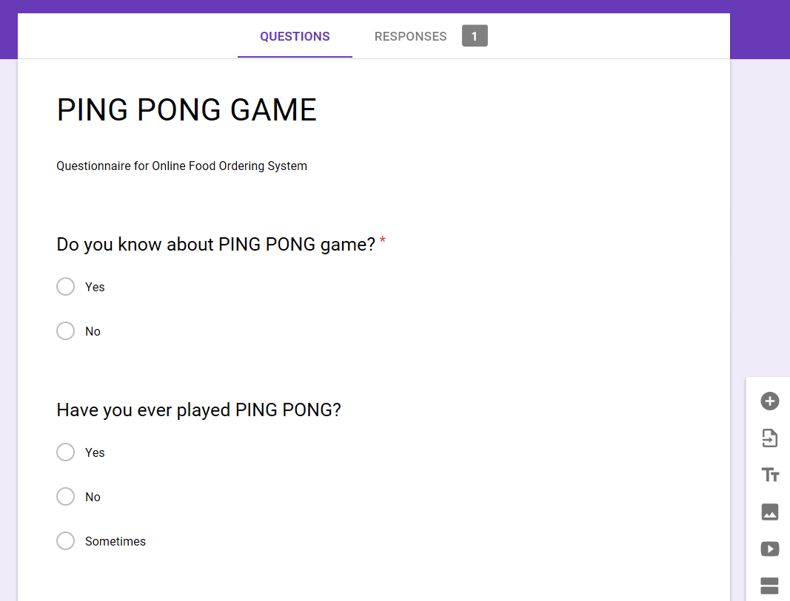

Figure question asked

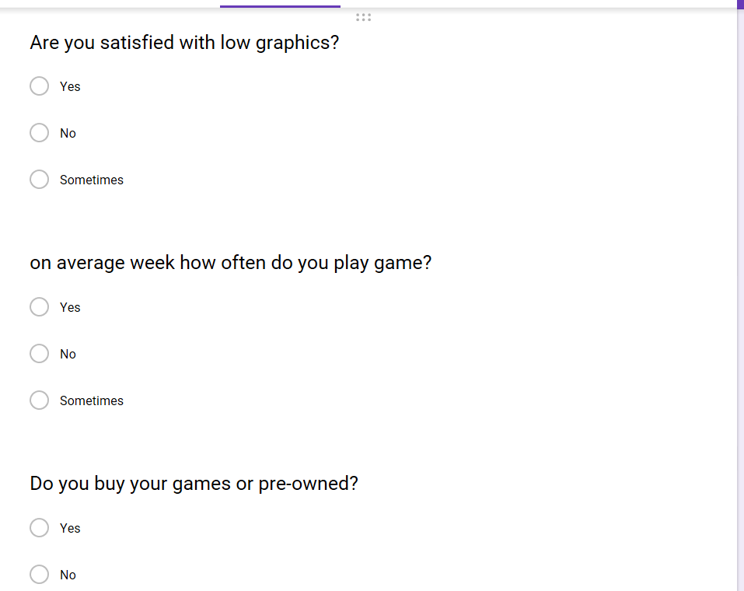

Figure question asked

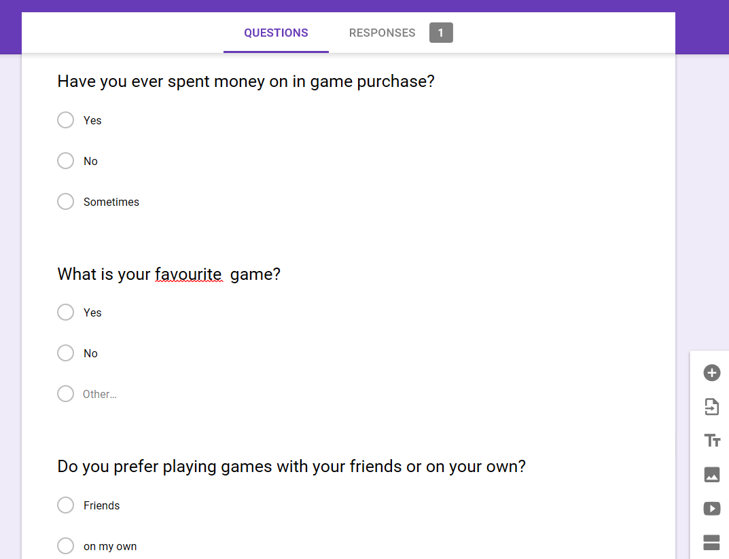

Figure question asked

**Feasibility Study**

Feasibility is outlined as the applicable extent to that a project are often performed with success. To evaluate practicability, a feasibility study is performed, which determines whether or not the resolution thought of to accomplish the wants is applicable and practicable within the software system. Information such as resource convenience, cost estimation for software system development, benefits of the software system to the organization once it is developed and price to be incurred on its maintenance square measure thought of throughout the practicability study. The objective of the feasibility study is to determine the explanations for developing the software system that's acceptable to users, adaptable to modification and conformable to established standards. Several types of feasibility study are there some of them are:

**Technical Feasibility Study**: it gathers the vital information of the current resources such as hardware, software and technology which are meant to complete the needs of requirements of the clients within the software in the given proper time and budget.

For the game development I have selected technical study to be sure that whether our company has got enough resources to complete this game in given time and the budget allocated by the clients or not. As per our analysis we have gather all the resource so we will finish our project and made it successful.

**Economic Feasibility:** in this feasibility we study about the economical part whether the company will be benefit by doing this project or not. It contains the development team cost, hardware cost for the project and software too and many more. It is necessary to gather the information about the expanses or cost while doing this project.

For this project all the cost has been allocated which is fit under the budget so our company will be in profit by doing this project.

**Social Feasibility Study**: Social feasibility is a study of however one act with another during a system or organization. It’s also identified as a social impact analysis. This process provides a framework for analyzing and incorporating the style and delivery of comes. It’s also used for rate.

It helps to analyze the social impact of our project and also helps us to reduce the risk of failure of our project in future.

**Environmental Feasibility Study**: it shows how our project will affect by the environment means our project/game will sustain how much longer on this technical world.

**Market Feasibility Study**: it is a type of analysis where we gain the knowledge about market target distinguishing the main threats of the project and also helps us to find the solution to overcome it. It helps us to growth our business in our projected area.

By doing market feasibility study it helps to achieved our goal project in a successful way.

# ANALYSIS METHODOLOGY

Methodology is the systematic, theoretical analysis of the methods applied to a field of study. It comprises the theoretical analysis of the body of ways and principles associated with a branch of data. Typically, it encompasses concepts such as paradigm, theoretical model, phases and quantitative or qualitative techniques. Several types of methodologies and some of them are:

* Hard Approach
* Soft Approach
* Combined Approach.
* Object-Oriented Methodology.
* Process-oriented Methodology.

I have used soft approach for this project to give the better output for the project. The Hard Systems Approach (HSA) will be wont to address each qualitative and quantitative issues. It involves a step-by-step procedure, which will be repetitive, and the method ought to be revised if new data involves lightweight oar later stage within the process changes the situational perspective. In my project it helps us to identify the problems easily which will be very helpful while developing game and also using hard approach we can easily describe our situation of the project with the help of diagram which will be very helpful for reach our goal. It will be helpful for our project by following ways:

* By analyzing the situation, it helps us to identify the problems.
* Describe the problems/situation and present in diagram so everyone will understand easily.
* Identify metrics by that you can recognize if we've got achieved our goal and generate ideas of routes to achieve the perfect state of affairs.
* We can follow the routes and we can see the output and evaluate it.

**System requirement specification:**

A system needs specification is ordinarily created in response to a user needs specification or different expression of requirements, and is then used as the basis for system design. The system needs specification usually differs from the expression of requirements in each scope and precision: the latter might cowl each the envisage system and the setting within which it'll operate, but might leave several broad ideas unrefined.

Functional requirements:

the functional requirements are shown in table below:

|  |  |  |  |  |
| --- | --- | --- | --- | --- |
| Requirement ID | Description | Input | Remark | Dependency |
| PP-01 | Registration | Name, password, email, phone number | New user register for the game | N/A |
| PP-02 | Login | Username and password | Dashboard will be opened where people login to access the game | PP-01 |
| PP-03 | Manage user | Manage user age gender | user should be managed like gender and many more | PP-01 |
| PP-04 | Manage Profile | Manage profile picture delete profile | Profile of the player should be managed | PP-01, PP-02 |
| PP-05 | Selection of Bat | Choice of bat | Choices of bat according to their points | PP-05 |
| PP-06 | Player score | score | Score of the player will be generated at the end of game | PP-04 |
| PP-07 | Player Rank | position | Position of the player should be determined according to score | PP-06 |
| PP-08 | Save game | save | Game will be saved if the user wants | PP-04 |
| PP-09 | Select Level | level | User will have option to select | PP-04 |
| PP-10 | Reset game | reset | If user want to start the game again | PP-09,PP-04 |

**Nonfunctional requirements**

Non-functional demand (NFR) is a requirement that specifies criteria that may be accustomed choose the operation of a system, rather than specific behaviors. On-functional requirements square measure usually known as "quality attributes" of a system. Some of the non-functional requirements are given below:

Performance: the system should be more responsive so the user doesn’t have any problem to interact and also the user interface of the system should be better.

Security: system should be confidentiality private information of the player should be protected like number of the player.

Reliability: for better performance system should be steady. Software should not be slow or hang or crash for better.

Scalability: to ensure that the software is capable or not in the terms o the scalability.

Portability: while placing the software in different devices or platform people don’t have to face any problem.

Availability: to ensure that even the system will work if any breakdown happens in the server. Backup of the user will be created.

**MoSCoW prioritization:**

There is various type of prioritization in DSDM which leads the project among them MoSCow prioritization is the most successful among them. DSDM stand for Dynamic systems development method for become more successful while doing the project give the more importance the requirement by using words which have meaning is MoSCoW prioritization.

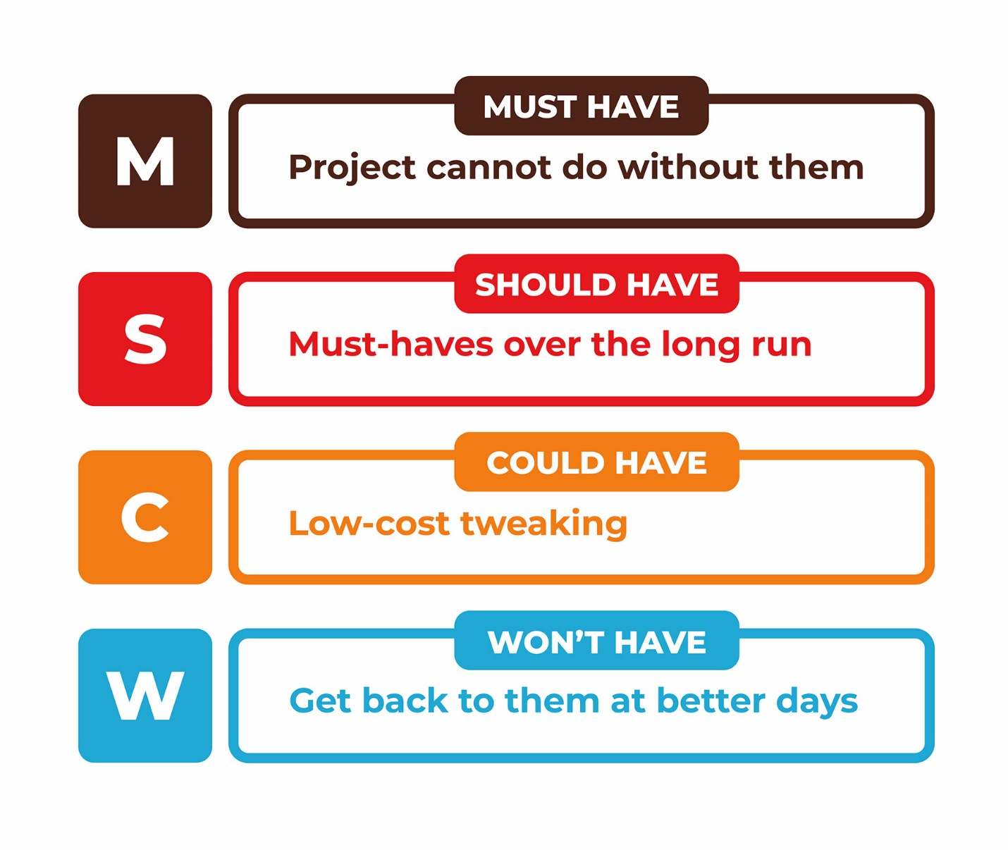

Figure 4 MoSCoW prioritization

|  |  |  |
| --- | --- | --- |
| S.N | Requirements | MoSCoW |
| 1 | registration | Must Have |
| 2 | Login | Must Have |
| 3 | Manage User | Must Have |
| 4 | Manage Profile | Should Have |
| 5 | Selection of bat | Could have |
| 6 | Player score | Must Have |
| 7 | Player Rank | Should Have |
| 8 | Save game | Should have |
| 9 | Select level | Must have |
| 10 | Reset game | Could have |

**Hardware/software specification**

For the project good hardware and software must be most important part to complete the task. The minimum requirement for the game run into the system is:

|  |  |
| --- | --- |
| **Hardware Specification** | **Software Specification** |
| RAM: Minimum 1 GB | OS: Windows 7, windows 10, MAC, Linux |
| Storage: Minimum 10 GB | Android based application |
| Processor: 1.5 GHz | Adobe Flash Player |

**USE CASE DIAGRAM**

Use case is a type of diagram which is used in system analysis to recognize, justify and manage the system requirements. In this diagram we can see the how system works/interaction between the system and user where user is the actor. In diagram we can see the relation between actor and system. Use case diagram is shown in below:

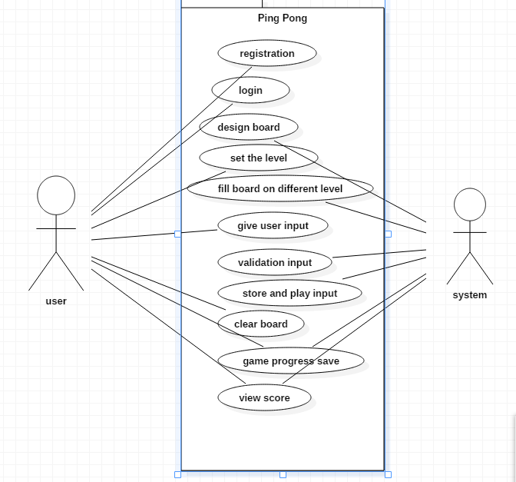

Figure 5 initial use case diagram

The above diagram shows the how the user and actor works

Admin and user both can register the system

Admin and user both log in to the system

User can delete their account

User select level which they want to play

User can change their point

User can see their score

User can save their game progress

**System architecture:**

Systems Architecture is a generic discipline to handle objects (existing or to be created) referred to as "systems", in a way that supports reasoning concerning the structural properties of those objects. In project three tier system architecture to develop our system. As I have already mentioned in proposal about three tier system architecture in briefly so in my project it will helps in following ways

It helps to improve the horizontal scalability, performance of the system and availability of the system.

Due to its three-tier nature every part should be developed concurrently so developers will easily finish their part in time.

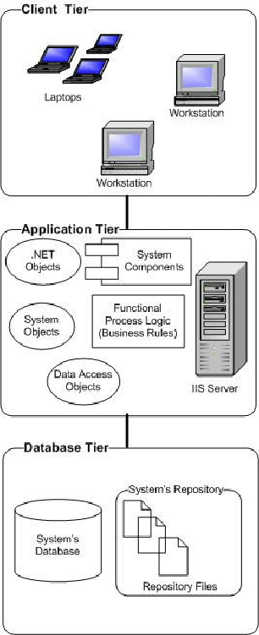

Figure 6 three-tier structure

**NLA**

Process involved in NLA are:

i) Identify nouns

ii) Identify Verbs

iii) Identify Adjective

iv) Identify relationships

The candidate’s class, verbs and adjective of the system are given below:

|  |  |  |
| --- | --- | --- |
| Nouns (Classes) | Verb (Function) | Adjective (Attributes) |
| Admin | Login | Admin id, Admin Name |
| user | update | delete |
| leaderboard | level | difficulties |
| Main index | Play game | Reset game |

**CLASS DIAGRAM:**

Class diagram is defined as the distinguish of the interrelationship and source code dependencies among the candidate classes in the Unified Modeling Language. Class allocate the methods and also the variables of an object.

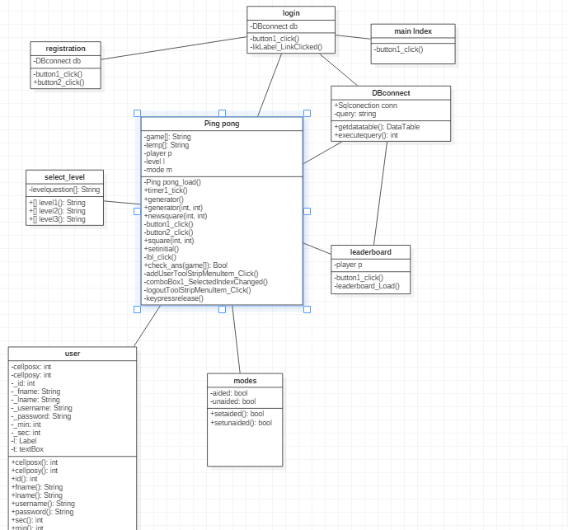

Figure 7 initial class diagram